**Lab Exercise 1- Working with Git Revert**

**Lab Exercise: Git Revert**

This exercise will guide you through reverting changes in Git. The git revert command is used to create a new commit that undoes the changes introduced by a previous commit without modifying the history.

**Objective**

* Learn how to use git revert to undo changes from specific commits.
* Practice handling merge conflicts during a revert.

**Prerequisites**

1. Install Git on your system.
2. Set up a Git repository:

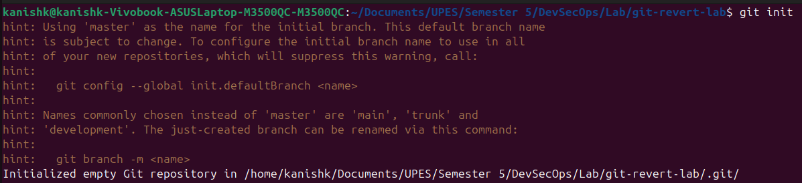

**Steps**

**1. Set Up the Repository**

1. Create a file:



1. Stage and commit the file:



1. Add more changes:



1. Add another change:



1. Verify the commit history:



**2. Revert the Last Commit**

1. Revert the most recent commit:



1. Git will open a text editor for the commit message. Save and close the editor to complete the revert.
2. Verify the contents of file.txt:

Check the commit history:



**3. Handle Merge Conflicts During Revert**

1. Modify file.txt:



1. Revert the second commit (8b2a1c1 again) to trigger a conflict:

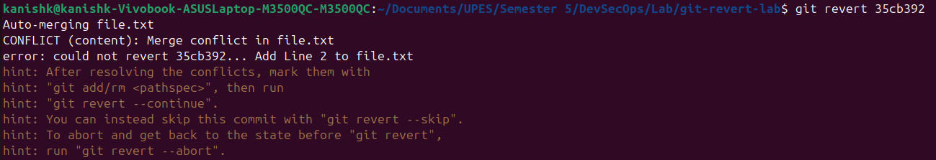

1. Git will indicate a conflict. Resolve it:
   * Open file.txt and remove conflict markers.
   * Keep the desired lines.



1. Stage the resolved file:



1. Complete the revert:

